Table of Contents

Abstract 4

Project Specification 5

Chapter 1: Introduction 6

1.1 Objectives 6

1.2 Basic Operations 6

Chapter 2: Hardware Description 7

2.1 IR Sensors 7

2.2 Motor Driver 8

2.3 Arduino UNO 9

2.4 DC Motors 10

Chapter 3: Working Principle 11

Chapter 4: Design and Implementation 13

4.1 Source Code 13

4.2 Circuit Diagram 15

Chapter 5: Tables 16

Chapter 6: Simulation and Result 17

Chapter 7: Cost of Project 20

Chapter 8: Conclusion 21

Bibliography 22

**Table of Figures**

Figure 1: Block Diagram for Line Follower Robot. 6

Figure 2: IR Working Diagram. 7

Figure 3: Pin Diagram of L293D (Motor Driver). 8

Figure 4: Arduino UNO Pin Diagram. 9

Figure 5: Robot Moving Forward. 11

Figure 6: Turning Left. 11

Figure 7: Turning Right. 12

Figure 8: Stop the Robot. 12

Figure 9: Circuit Diagram of Line Follower Robot Using Arduino. 15

Figure 10: Robot Stops. 17

Figure 11: Robot Moves Forward. 17

Figure 12: Robot Turns Right. 18

Figure 13: Robot Turns left. 18

Figure 14: Robot Stops. 19

**Table of Tables**

*Table 1: Robot Motion* 16

*Table 2: Behaviour of Sensor* 16

Abstract

This paper is all about the “Line Follower Robot Using Arduino” circuits. Line follower is an intelligent robot which detects the visual line embedded on the floor and follows it. The path is predefined and is visible like a black line on the white surface or white line on the black surface. In order to detect these lines various sensors can be employed in the robot. Generally, the infrared Sensors are used to detect the line which the robot has to follow. The robot movement is automatic and can be used for the long distance application. This project is developed to know the basics of combination of hardware and the software. Since the microcontroller used in this project is very user friendly. The robot is driven by the DC gear motors to control the movements of the wheels. The Arduino Uno interface is used to perform and implement algorithms to control movements of the motors, steering the robot to travel along the line smoothly. The goal of this project is to make the automated line tracing robot that follows black line on the white surface.

Project Specification

* The robot is fully automated that it follows a particular line to move on the surface.
* Infrared sensors are employed in the robot to detect the line on the surface that is black line on the white surface.
* Another IR sensor is fitted on the either side of robot this can be used to stop the robot at a particular place in between the path.
* Arduino Uno interface is used for the combination of hardware and software and code written in arduino helps to control the movement of the wheels.
* DC gear motor is used to drive the wheels and 5V power supply is provided to run the robot.

# Introduction

The main aim of any robot is to reduce the human effort. According to the purpose different types of robot are designed for the practical purposes. This line follower robot is fully automated as it follows the black line on the white surface for its movement. This line following robots consists of two wheels. The infrared sensor is mounted with the robot in order to communicate with microcontroller in sensing the line that had drawn by line tracer on a white surface. One more infrared sensor is fitted on the either side of the robot. This sensor will make the robot to stop for particular time in between the path. So this can serve as stoppage at a station. The project is constructed using an Arduino UNO Board as a microcontroller, two DC gear motors, and 12V DC supply. The block diagram of the system is shown in Figure 1. The main objectives of the study include-

* To introduce the robotic system.
* To apply the C programming language systematically.
* To experiment on the compatibility of the working relation among the Arduino microcontroller and other components used in robot.

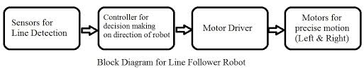

Figure : Block Diagram for Line Follower Robot.

## Objectives

The objectives of the project are

* The robot must be capable of following a line.
* Robot should be able to take various degrees of turn.
* Robot should be able to stop at a station for particular time.

## Basic Operations

The basic operations of line follower robot are as follows:

* Capture the line position with the help of the infrared sensor mounted at the front-end of the robot.
* Infrared sensors send the data to microcontroller fitted in the Arduino UNO and corresponding to the data arduino control the motor with the help of motor driver.

# Hardware Description

The required hardware and detail description of components used is discussed below:-

## IR Sensors

The Infrared (IR) sensors consist of Infrared (IR) LED and Infrared (IR) photodiodes. The IR LED is called photoemitter and IR photodiode is called receiver. The IR light emitted by the LED strikes the surface and gets reflected back to the photodiode. Then the photodiode gives an output voltage which is proportional to the reflectance of the surface which will be high for a light surface and low for dark surface. Light colored objects reflect more IR light and dark colored objects reflect less IR light.

The sensor on the left is named as f1 and the sensor on the right is named as f2.

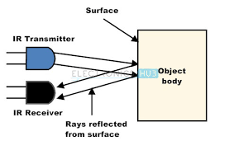

Figure : IR Working Diagram.

## Motor Driver

Motor driver acts like a current amplifier. Motor driver is used for controlling the current in the motor. The motor driver will provide high current to the motor when low current is received in the circuit. A high value of current is needed to drive these motors. The IC L293D will be able to control two dc motors simultaneously. The motor can be rotated in both forward and reverse direction. Motor driver after taking input signals from the microcontroller will generate the output for the motor and thus controls the motors when the robot needs to turn left or right. It completely controls the movement of dc motors.

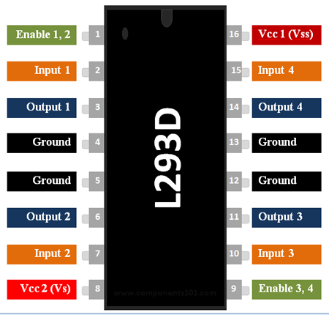

Figure : Pin Diagram of L293D (Motor Driver).

## Arduino UNO

In our Project we have used a microcontroller to control whole the process of system that is Arduino. Arduino is an open source hardware and very useful for project developments. There are many types of arduino like Arduino UNO, arduino mega, arduino pro mini, Lilypad etc. available in the market. Here we have used arduino UNO in this project as it is easy to handle for the beginners. A program for Arduino can be written in any programming language with compilers that produce binary machine code for the target processor. The Arduino provides the integrated development environment (IDE), which is a cross platform application written in programming language JAVA. This IDE also supports C and C++ using certain rules of code structuring.

### Features of Arduino UNO

* Microcontroller: ATmega328
* Operating Voltage: 5V
* Digital I/O Pins: 14 (of which 6 provide PWM output)
* Analog Input Pins: 6
* DC Current per I/O Pin: 40 mA
* DC Current for 3.3V Pin: 50 mA etc.

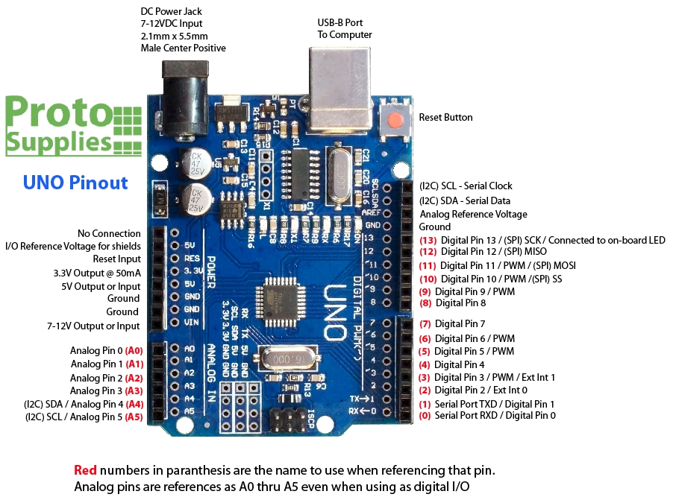

Figure : Arduino UNO Pin Diagram.

## DC Motors

Motor is a device that converts any form of energy into mechanical energy. In construction of the robot motor plays an important role by giving movement to the robot. DC motor are easy for controlling. Generally DC motor has two signals for its operation. Reversing the polarity of the power supply across it can change the direction of rotation. Speed can be varied by changing the voltage across the motor.

Here 12V DC Motor is used for the movement of the robot.

Resistance of used motor is approximately 17 ohms.

# Working Principle

In the program both the IR sensors have to initialize. Four output pins of the motor have to be initialized. Three variables have to be declared, for the IR sensors. Two of three variables will read the value of left and right sensors respectively and the third variable will read the value of another IR sensor which is used as stoppage at station. If the third sensor detects any black spot on either side of its path all the motors should stop, the four output pins of the motor drive should be programmed as LOW or HIGH, which means they should stop working then robot, will wait there for five seconds and then again starts moving.

**For moving forward: -** One pin on either side of the motor will be HIGH and the other two pins will be LOW. This makes the left and right motor to rotate in clockwise direction and hence the robot moves forward.

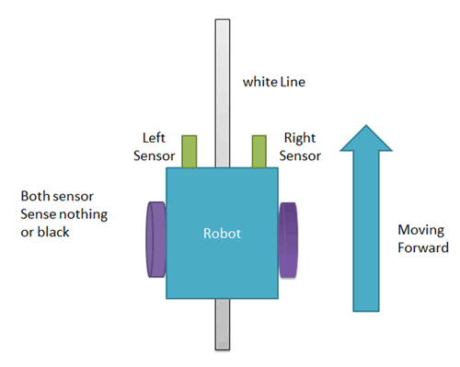

Figure : Robot Moving Forward.

**For taking left turn: -** When only left IR sensor detects the black line then the robot has to turn left, for that only right motor has to work. When the left motor stops and the right motor is rotating in clockwise direction the robot will turn left and to achieve this one pin of the right motor should be HIGH and all the other pins should be LOW.

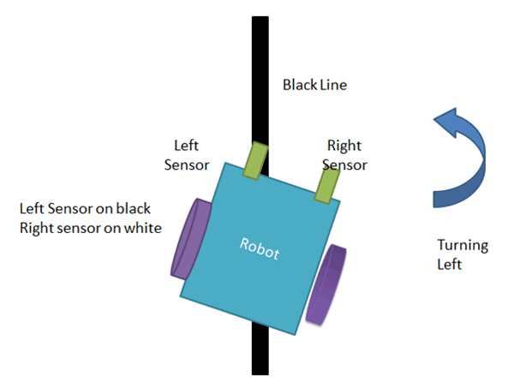

Figure : Turning Left.

**For taking right turn: -** When only right IR sensor detects the black line then the robot has to turn right, for that only left motor has to work. When the right motor stops and the left motor is rotating in clockwise direction the robot will turn right and to achieve this one pin of the left motor should be HIGH and all the other pins should be LOW.

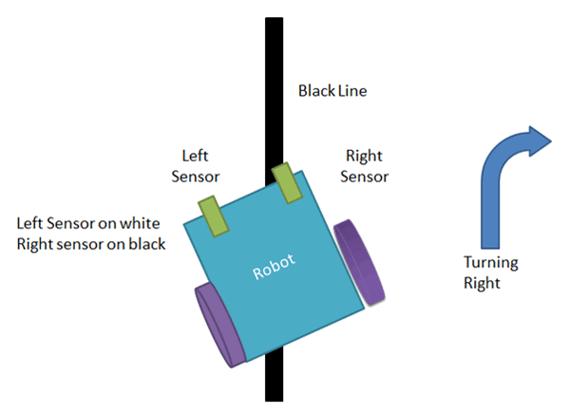

Figure : Turning Right.

**When robot stops: -** When both the sensors are on the black line then the robot will stop moving.

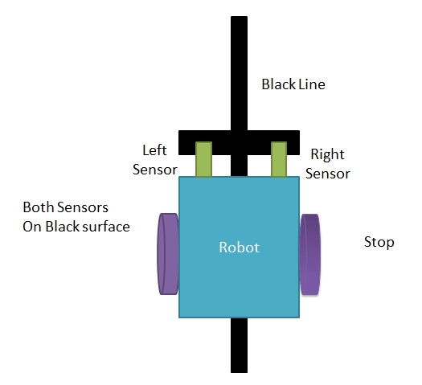

Figure : Stop the Robot.

# Design and Implementation

## Source Code

int f1,f2,z1 = 0; //Declaring Variables.

void setup() {

pinMode(A0, INPUT); //Input pin number A0 as IR Sensor1

pinMode(A1, INPUT); //Input pin number A1 as IR Sensor2

pinMode(A2, INPUT); //Input pin number A2 as IR Sensor3

pinMode(8, OUTPUT); //Output pin number 8

pinMode(9, OUTPUT); //Output pin number 9

pinMode(10, OUTPUT); //Output pin number 10

pinMode(11, OUTPUT); //Output pin number 11

}

void loop() {

f1 = analogRead(A0); //Reading value from lEFT Sensor and storing in f1 variable.

f2 = analogRead(A1); //Reading value from Right Sensor and storing in f2 variable.

z1 = analogRead(A2); //Reading value from Station Sensor and storing in z1 variable.

if(z1<511) //Checking condition for Station.

{

digitalWrite(8, HIGH);

digitalWrite(9, HIGH);

digitalWrite(10, HIGH);

digitalWrite(11, HIGH);

delay(5000); //Wait at Station for 5 second.

}

else

{

if(f1 > 511 && f2 > 511) // Move Forward

{

digitalWrite(8, HIGH); //Assigning Digital Value as HIGH.

digitalWrite(9, LOW); //Assigning Digital Value as LOW.

digitalWrite(10, HIGH); //Assigning Digital Value as HIGH.

digitalWrite(11, LOW); //Assigning Digital Value as LOW.

}

if(f1 > 511 && f2 < 511) //Turn Right

{

digitalWrite(8, HIGH); //Assigning Digital Value as HIGH.

digitalWrite(9, LOW); //Assigning Digital Value as LOW.

digitalWrite(10, LOW); //Assigning Digital Value as LOW.

digitalWrite(11, LOW); //Assigning Digital Value as LOW.

}

if(f1 < 511 && f2 > 511) //Turn Left

{

digitalWrite(8, LOW); //Assigning Digital Value as LOW.

digitalWrite(9, LOW); //Assigning Digital Value as LOW.

digitalWrite(10, HIGH); //Assigning Digital Value as HIGH.

digitalWrite(11, LOW); //Assigning Digital Value as LOW.

}

if(f1 < 511 && f2 < 511) //Stop

{

digitalWrite(8, HIGH); //Assigning Digital Value as HIGH.

digitalWrite(9, HIGH); //Assigning Digital Value as HIGH.

digitalWrite(10, HIGH); //Assigning Digital Value as HIGH.

digitalWrite(11, HIGH); //Assigning Digital Value as HIGH.

}

}

## Circuit Diagram

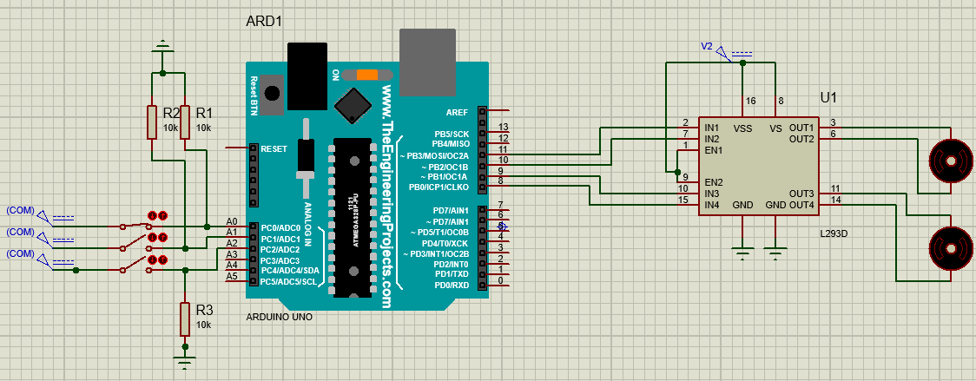

Figure : Circuit Diagram of Line Follower Robot Using Arduino.

# Tables

*Table 1: Robot Motion*

|  |  |  |
| --- | --- | --- |
| **Left Motor** | **Right  Motor** | **Robot Movement** |
| Straight | Straight | Straight |
| Stop | Straight | Left |
| Straight | Stop | Right |
| Stop | Stop | Stop |

*Table 2: Behaviour of Sensor*

|  |  |
| --- | --- |
| **Station Sensor** | **Behavior** |
| HIGH | Wait for 5 seconds |
| LOW | Motion with respect to IR sensors |

# Simulation and Result

**Case 1:-** when the side sensor is on that is this sensor is on the black spot then irrespective of other two sensors reading both the motor stops working. The robot will wait for five seconds and then again starts moving.

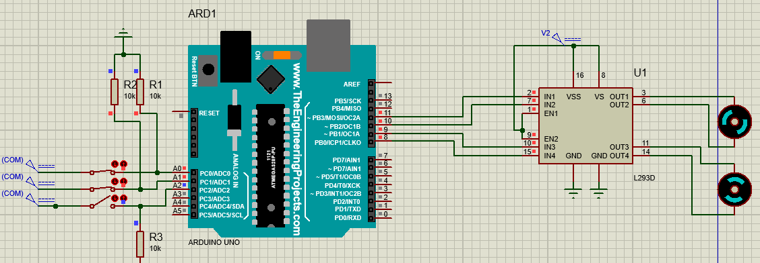

Figure : Robot Stops.

**Case 2:-** when the side sensor is off that means it is on the white surface and the other two sensors are also off that is they are also on the white surface then both the motor will be in working state and robot will move in forward direction.

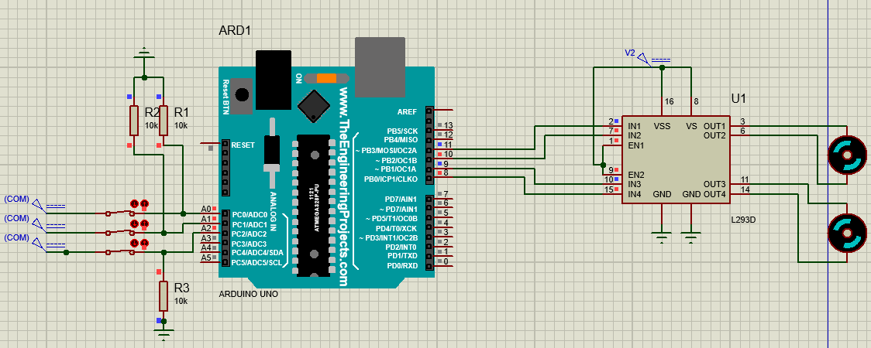

Figure : Robot Moves Forward.

**Case 3:-** when the side sensor and the right sensor is in off state that is they are on the white line and the left sensor is in the on state that is this is on the black line then the robot will turn in right side.

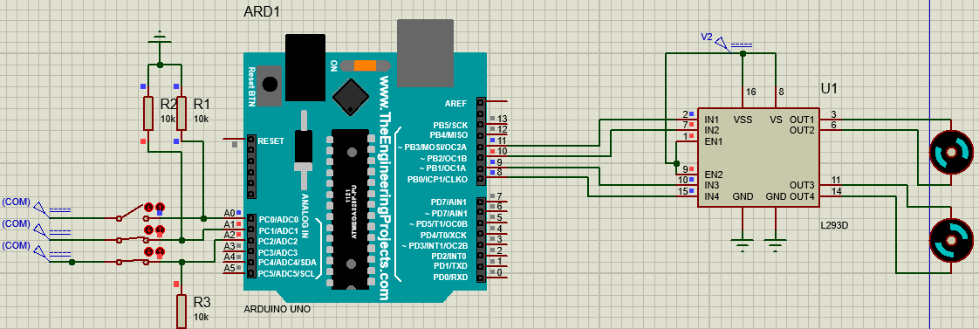

Figure : Robot Turns Right.

**Case 4:-** when the side sensor and the left sensor is in off state that is they are on the white line and the right sensor is in the on state that is this is on the black line then the robot will turn in left side.

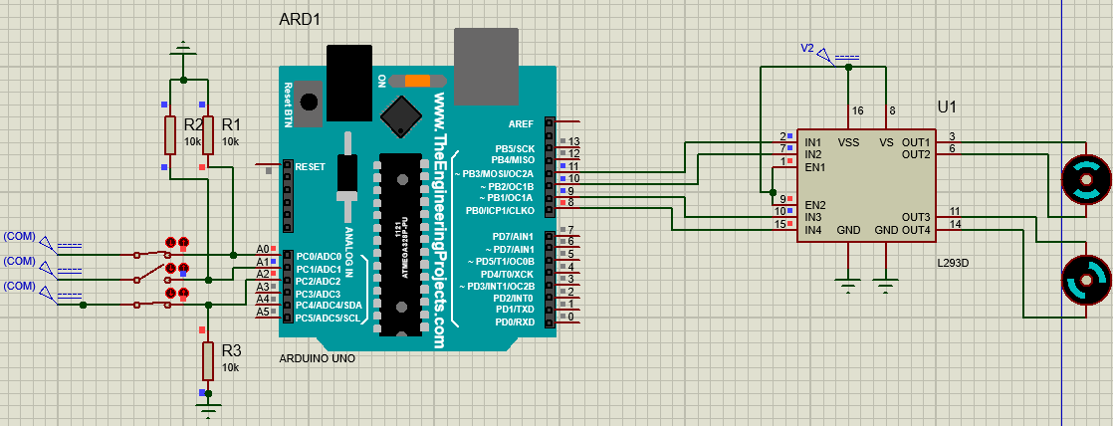

Figure : Robot Turns left.

**Case 5:-** when the side sensor is in off state that is this is on the white line and the left sensor and the right sensor are in the on state that is they are on the black line then the robot will stop moving.

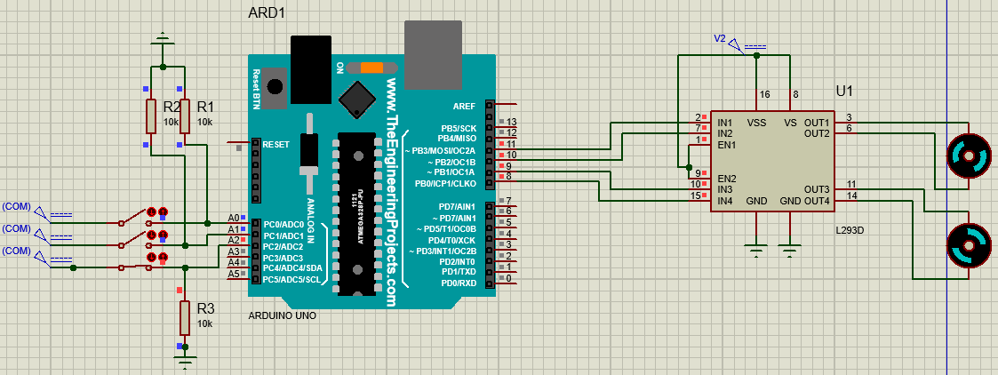

Figure : Robot Stops.

# Cost of Project

|  |  |  |
| --- | --- | --- |
| **Name of Component** | **Number of Component** | **Cost of Component** |
| Arduino UNO | 1 | Rs.345 |
| Motor Driver | 1 | Rs.80 |
| DC Motor | 2 | Rs.500 |
| IR sensors | 3 | Rs.30 |
| Resistance(10k) | 4 | Rs.8 |
| Resistance(150ohm) | 2 | Rs.4 |
| **TOTAL** Rs.967 | |

# Conclusion

The line follower robot is automated system that has the ability to recognize its path, move and change the robot’s position towards the line is the best way to remain on the track. This project report presents a photodiode sensors based line follower robot design which always directs along the black line on the white surface.

This project pointed towards the understanding of electronics, hardware and their integration using programming. This project is completed and finished by studying Arduino UNO, DC motor working principle, line tracing sensors and C programming.

Bibliography

1. International Journal of Research and Scientific Innovation (IJRSI) | Volume V, Issue IV, April 2018.
2. International Journal of Science, Engineering and Technology Research (IJSETR) Volume 7, Issue 8, August 2018
3. Deepak Nair, Santosh Shah and Saumitra Debnath. Design Lab Project – Rules and Guidelines. The LNMIIT, Jaipur, 2017.